PART 1

1.

1. Code SnippetGraphical user interface, text

   Description automatically generated

b)Current Outcome

c)Desired Outcome

The web page's present date is displayed using JavaScript code.

The constant variable "currentDate" receives a new Date object, which is then given to it. The toDateString() method is used to transform the "currentDate" object's representation of the current date and time into a human-readable format depending on the user's system clock. The "formattedDate" constant variable is given the output text.

d)Code Snipped of desired outcome

e) New outcome of the code.

2.

a) Code Snippet

b) Current Outcome

c)Desired Outcome

Using the getElementById() method, this code generates a button with the ID "change-btn" and assigns it to the "button" variable.The addEventListener() method is then used to add an event monitor to the button. The function provided in the second argument is executed by the event listener when it detects a "click" event on the button.A variable named "imageUrl" is defined inside the function and given the value "bg1.jpg". You could use the URL of any other picture you want to use as the background image in lieu of this.The URL of the image provided in the "imageUrl" variable is then set as the backgroundImage property of the document's body element. With the aid of string concatenation, the URL is added.

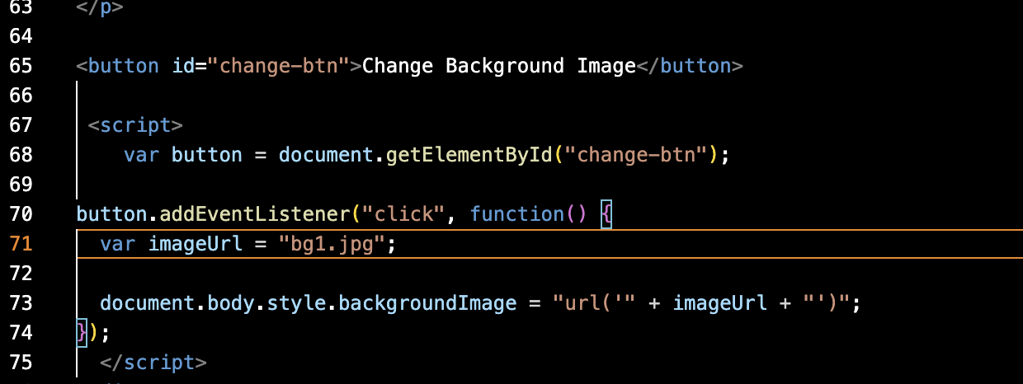

d)Code Snipped of desired outcome

e) New outcome of the code. 